Asset Warranty and Maintenance Tracker Milestone 2: Initial Deployment
Andres Rosas Ortiz
000800390
Deployment Platform and Settings
The system is deployed to a droplet on DigitalOcean. The droplet uses standard configurations:
- Ubuntu 24.04 LTS
- 1 vCPU / 1 GB RAM
- Toronto region
- $6/month basic tier
The database is PostgreSQL and is running on Supabase’s free tier.
Total cost remains the same as the proposal estimate of $18 USD for three months.
The application is live at this address http://165.245.231.243/
Components
The droplet also consists of these components:
- Nginx
  - daemon listening on port 80 and handles all incoming traffic
  - serves the compiled React front end as static files
  - requests for a page such as /login are handled by nginx
  - any request beginning with /api/ gets forwarded to Node on port 3001
- Node/Express
  - runs on port 3001, only accessible from the droplet
  - handles authentication and database access
  - runs under PM2 process manager so API keeps running when no terminal session is open, restarts automatically if it crashes, and is restarted when server reboots
- Supabase (PostgreSQL)
  - hosted externally, connection details in .env file
This design allows the front end and back end to be served from a single address, 165.245.231.243, instead of needing port numbers as well.
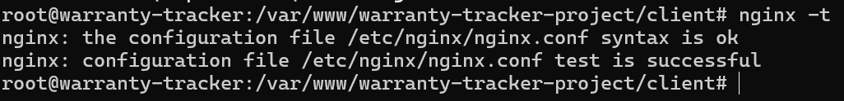
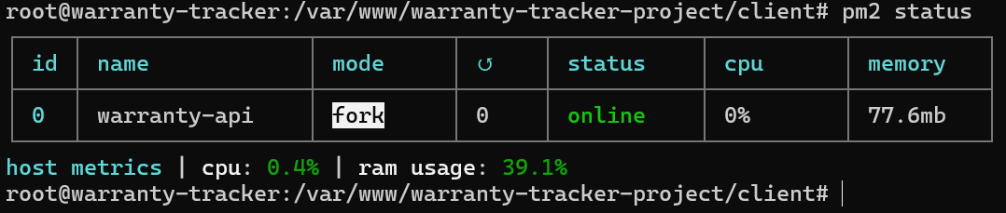
Security Measures Applied
- SSH access; key-based authentication (password not used)
- UFW firewall is configured, permitting only SSH, HTTP, HTTPS on ports 22, 80, and 443. Port 3001 is not publicly accessible so the API can only be accessed through nginx
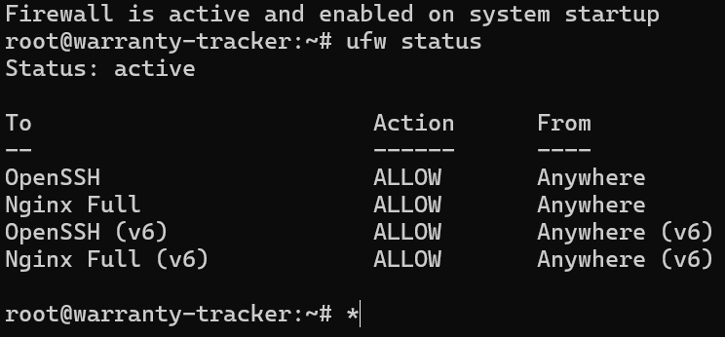
- Sensitive data like database credentials and JWT secret are stored as environment variables in an .env file, which is not included in commits. A different JWT secret is used in dev and production
Features Currently Deployed
- F1 — User registration with server-side validation
- F2 — Login and logout
- N3 — Password hashing with bcrypt
- N4 — Account lockout after five consecutive failed password attempts

Pushing Updates
Changes are made locally, committed and pushed to GitHub. Updates are pulled onto the droplet by logging in through SSH and using git pull. Backend changes are applied by restarting the API with pm2 restart warranty-api. Frontend changes are applied using npm run build.

Droplet’s IP in the browser redirects to Login page
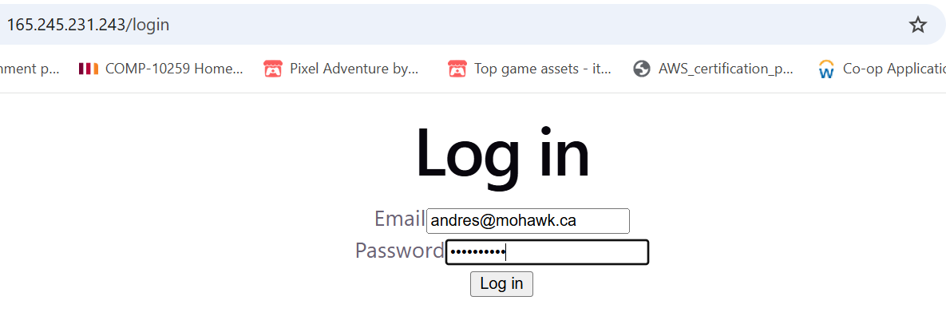

Successful login in loads Main Dashboard page


